**SWITCHES**

1. **3 pin Switch**
2. **4 pin Switch**

**3 pin Switch**

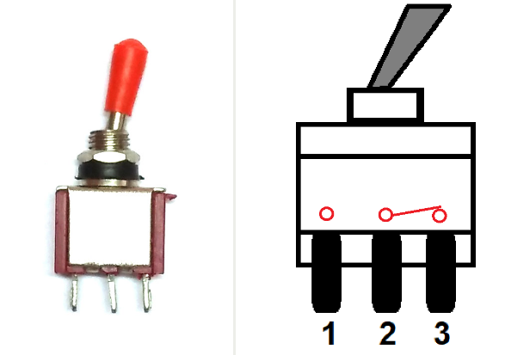

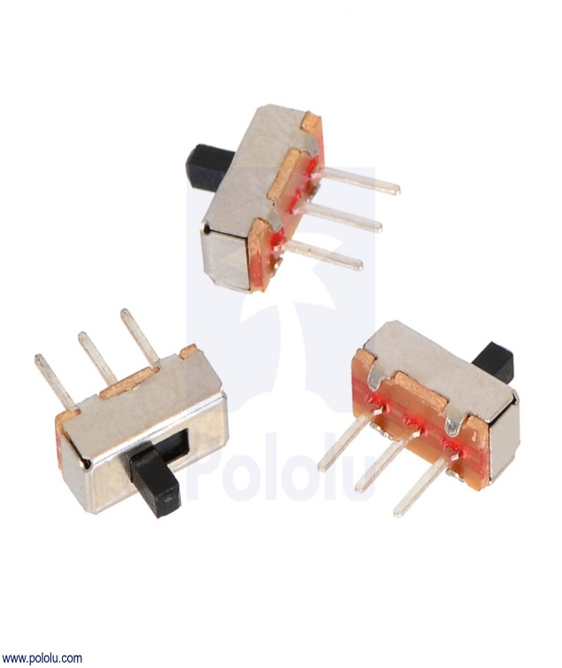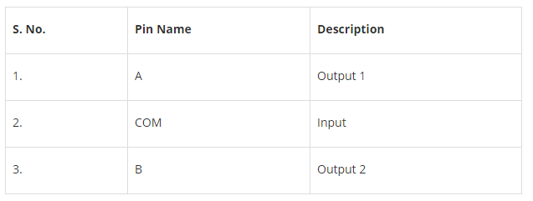

**Features and Specifications**

* 0.4volt-amps (max.) contact rating at 20v AC or DC (max.)
* Mechanical Life: 30,000 make-and-break cycles.
* 20mΩ (max.) contact resistance
* 100MΩ (min.) of Insulation Resistance
* 100mAfor both silver and gold plated contacts.
* Dielectric strength of 1000VRMS at sea levle
* Operating Temperature: -30°C to 85°C.

Brief about Toggle Switch?

There are four types of switches, classified below:

* Single Pole Single through (SPST)
* Single pole double throw (SPDT)
* Double pole, single throw (DPST)
* Double pole double throw (DPDT)

**SPDT Toggle Switch** is a three terminal switch, only one is used as input other two are as output. Therefore, we get two outputs, one from COM and A and second is from COM and B, but only one at a time. Mainly it is used in three-way circuit to turn **ON/OFF** an electrical appliance from two location.

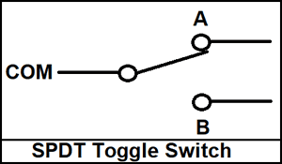

**4 pin Switch**

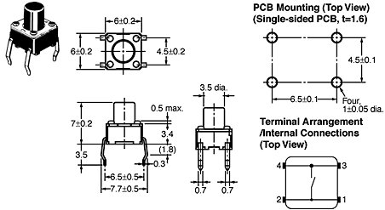

## Product Description:

Miniature 4-PIN Single Pull Single Throw switches. These are high quality momentary on switches. Perfect as a tactile reset switch. Mounts directly into standard breadboards. Rated up to 50mA.  
  
Features:  
  
• Power Rating: MAX 50mA 24VDC  
• Contact Resistance: MAX 100mOhm  
• Dielectric Withstanding Voltage: 250VAC for 1 minute  
• Contact Bounce: MAX 5mS  
• Operating Force: 2.55 +/-0.69 N  
• Return Fource: MIN 0.49 N  
• Travel 0.25 +0.2/-0.1 mm  
  
  
Documents:  
  
[Datasheet KSM0611EE](http://site.gravitech.us/Components/BUTT-4/BUTT-4_datasheet.pdf)